./

Learning Report – Applied System Development Life Cycle and Software Testing



|  |  |  |  |  |  |
| --- | --- | --- | --- | --- | --- |
| **Ver. Rel. No.** | **Release Date** | **Prepared. By** | **Reviewed By** | **To be approved By** | **Remarks/Revision Details** |
|  |  | Name/PS No | Name/PS No | Module Owner Name | Comments |
| 1 | 15/02/21 | Ravikumar M Pise  99003747 |  |  |  |
| 2 | 15/02/21 |  |  |  |  |
| 3 | 15/02/21 |  |  |  |  |
| 4 | 15/02/21 |  |  |  |  |

**Document History**

**Seat Belt Reminder**

**Introduction:**

The recent steady reduction in the fatality rate has been the result of a combination of a variety of factors including vehicle crash safety, engineering developments.

Seat belt is one of the primary safety feature used in vehicle to avoid major injuries to the driver driving the vehicle. Even after the government norm that is wearing of seat belt is mandatory, accidental injuries increase due to negligence of occupants in vehicle of wearing seat belt. If seat belt is not buckled correctly than the chances of accidental injuries increase. To avoid these, different companies found variety of seat belt systems such as passive seat belt system, automatic seat belt system, seat belt warning system and so on. So, in this project we have proposed better seat belt system than the present ones. This system comprises of sensor, micro controller and locking mechanism in wheel and seat belt. In this system vehicle propels only when seat belt and door are locked properly. According to our estimation this system can decrease fatality up to 70- 80% in comparison to present system.

**SWOT Analysis:**

|  |  |
| --- | --- |
| **STRENGTHS**   * Safety of user * Helps in Airbag operations | **WEAKNESS**   * Detects object as user * Driver negligence |
| **OPPORTUNITIES**   * Negligence of seat belt remainder should restrict the speed of vehicle | **THREATS**   * Sensor malfunction * Hardware Malfunction |

Inputs:

* Power
* Driver Occupation detection by sensor mat
* reed sensor for buckle status

Outputs:

* remainder light
* Chime

**Seat belt sensor**

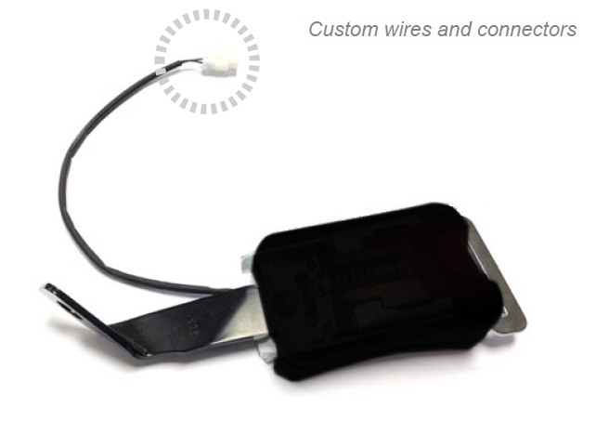

**Specifications:**

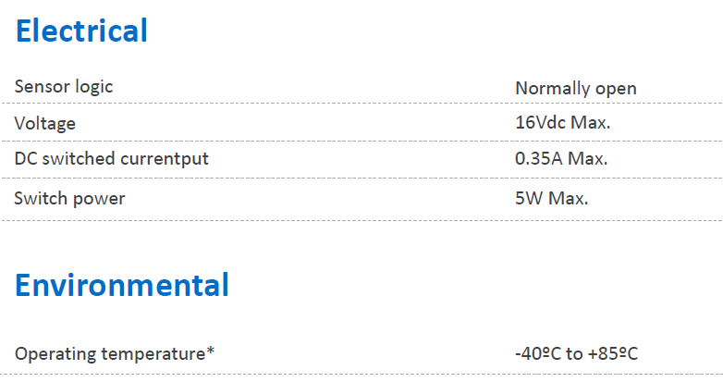

**Seat Occupancy Membrane Pressure Sensor for Car Seat**

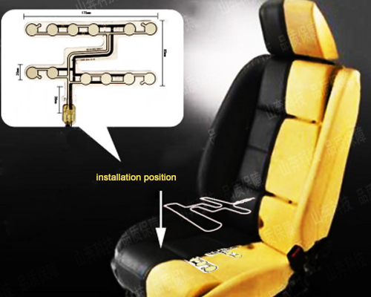

## **Specifications:**

|  |  |
| --- | --- |
| Rated Voltage | ≤50V DC |
| Rated Current | ≤ 100mA |
| Operating Power | ≤1W |
| Insulation Resistance | ≥100MΩ (250V DC) |
| Loop Resistance | 10Ω~2kΩ (based on the design) |
| Contact Resistance | 0.5 ~ 5Ω |
| Wire Lead Resistance | <1Ω/cm |
| Base Material Voltage Withstand | 1500V DC |

## Source:<http://www.jcftechnology.com/products_detail.php?id=48&menuid=5>

**Requirements:**

**HLR:**

* System should remind the user to wear the seat belt

**LLR:**

* Vehicle Power On/Off status
* User Occupation on Seat
* Seat Belt Buckled Status

**Algorithm:**

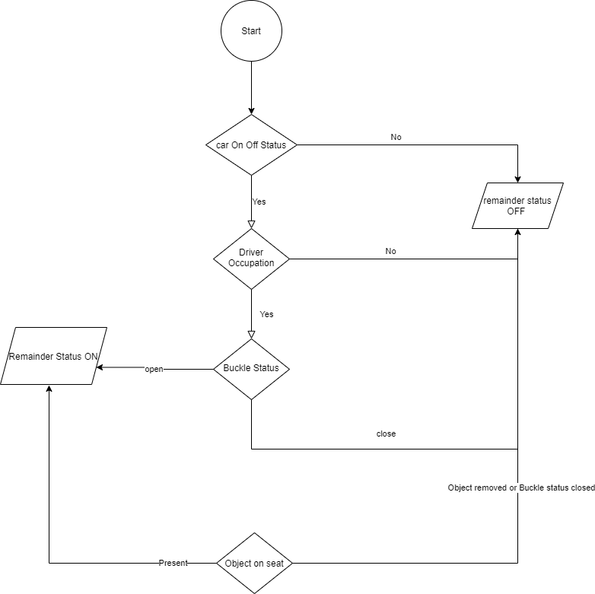

**Design: HL Design**

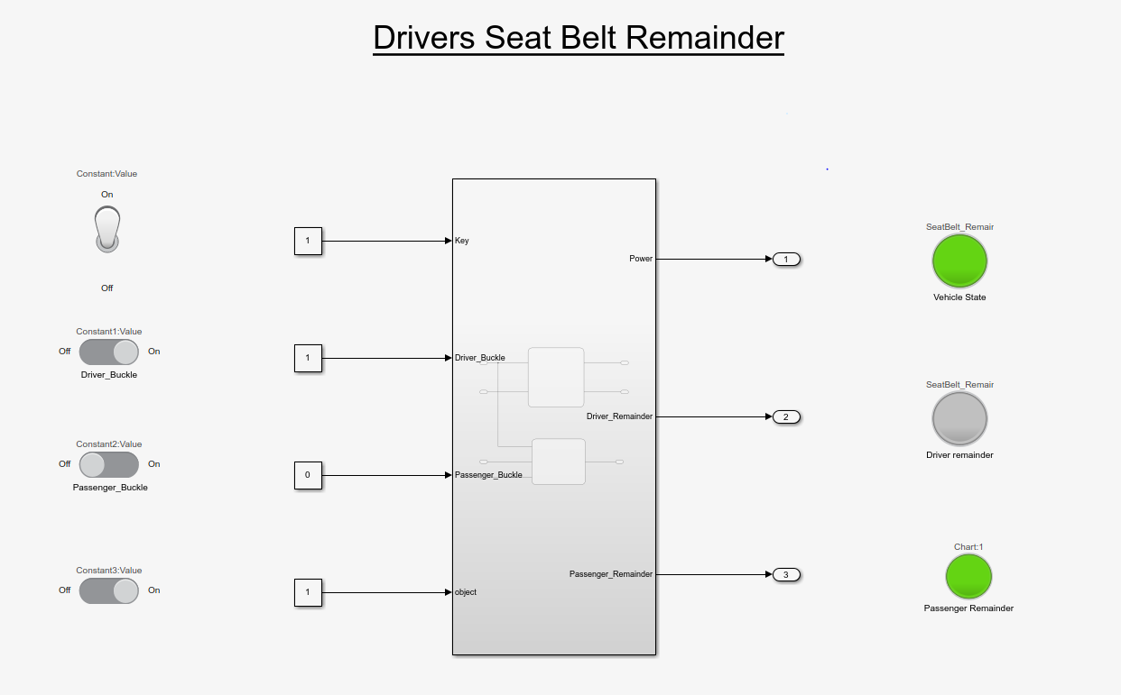

**LL Design**

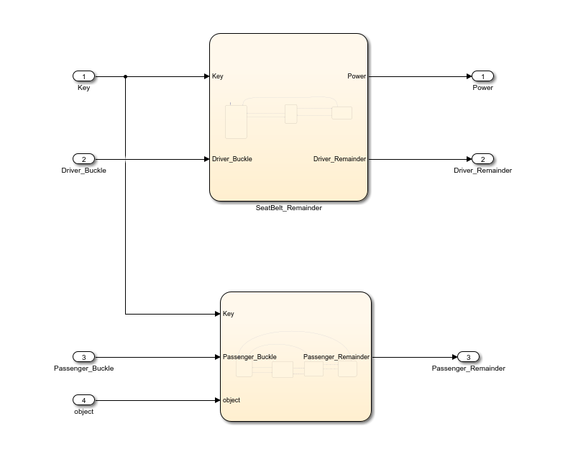

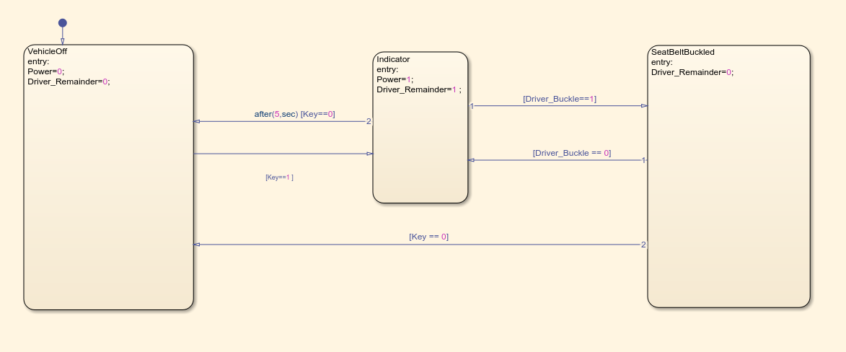

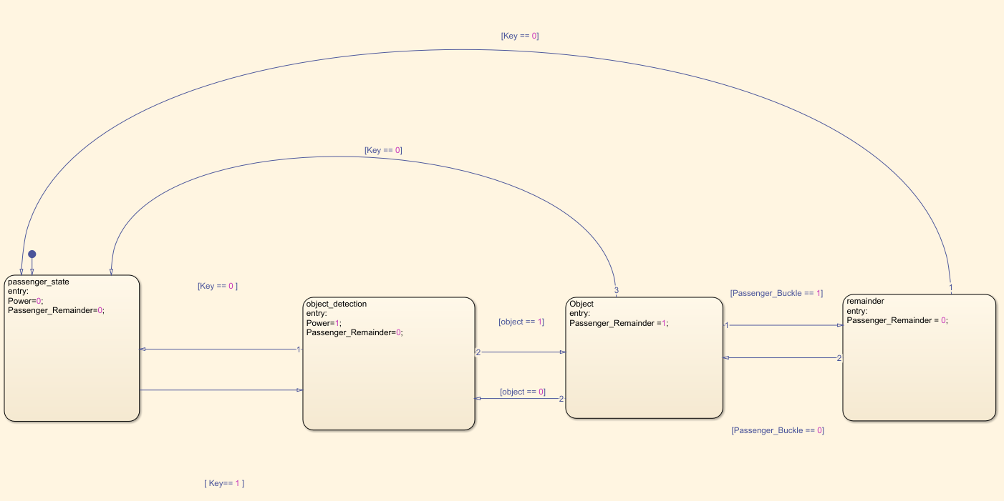

# Detailed Requirements:

|  |  |
| --- | --- |
| ID | Requirements |
| HLR_01 | Should remind the driver to fasten seat belt through display. |
| LLR_01 | Seat Sensor should be activated when driver sits upon it. |
| LLR_02 | Buckle sensor should give output as a reminder to the user through display and chime. |
| LLR_03 | Buckle sensor should be stop reminding when seat buckle is closed. |
| LLR_04 | When object is detected on passenger seat , remainder should turn off when buckled or object removed |

# Test Plans:

## High level Test:

|  |  |  |  |  |  |
| --- | --- | --- | --- | --- | --- |
| ID | Description | Input | Expected Output | Actual Output | Test Type |
| HLT_01 | Vehicle On/Off Status | Ignition On | Display Power On | Display Power On |  |
| HLT_02 | Seat Buckle should be working | Fasten seat belt | It should get buckled in. | Gets buckled in. |  |
| HLT_03 | Seat belt Reminder should not indicate. | Fastening of seat belt. | No output on the display to indicate. | No output on the display to indicate. |  |

Low Level Test:

|  |  |  |  |  |  |
| --- | --- | --- | --- | --- | --- |
| ID | Description | Input | Expected Output | Actual Output | Test Type |
| LLT_01 | Seat belt remainder should not indicate if seat is unoccupied | Passenger unbuckled | No indication | No indication |  |
| LLT_02 | Seat belt remainder should indicate if seat is occupied | Object Detected | Passenger Seat belt Indication | Passenger Seat belt Indication |  |
| LLT_03 | Seat belt remainder should stop indicating if object is removed | Object Removed | No Indication | No Indication |  |
| LLT_04 | Seat belt remainder should stop indicating if Buckled | Buckled | No Indication | No Indication |  |
| LLT_05 | Vehicle status Off | Buckled or Unbuckled | No Indication | No Indication |  |